|  |  |  |  |  |  |  |  |  |  |  |  |  |  |  |  |  |  |  |
| --- | --- | --- | --- | --- | --- | --- | --- | --- | --- | --- | --- | --- | --- | --- | --- | --- | --- | --- |
|  |  | eLab Book  HDip Web Development  **WEBDEV2017**  Firstname Surname  Stephen Gregan   |  |  | | --- | --- | | *Date : 23/10/2018* |  | | *Last Lab* |  | |  |  | | *Version:* | *1* | | *Status:* | *Draft / Release* | |  |  | |  |  | |  |  | |

Document Control

|  |  |  |
| --- | --- | --- |
| Contributors | | |
| **Name/Position** | **Organization** | **Contact Details** |
| Stephen Gregan | N/A | grego@live.ie |
|  |  |  |

|  |  |  |  |
| --- | --- | --- | --- |
| Version History | | | |
| **Date** | **Version** | **Status** | **Comments** |
| 23/10/2018 | V1.0 | Completed |  |
|  |  |  |  |
|  |  |  |  |

|  |
| --- |
| Changes since last version |
|  |

|  |
| --- |
| Known Omissions |
|  |

Table of Contents

1 Lab 1.1 : The Description 4

1.1 Problem definition 4

1.2 Design 4

1.3 Website folder structure 4

1.4 Code 4

1.5 Screens 4

1.6 Testing 4

1.7 References 4

2 Lab 1.1 : The Description 5

2.1 Problem definition 5

2.2 Design 5

2.3 Website folder structure 5

2.4 Code 5

2.5 Screens 5

2.6 Testing 5

2.7 References 5

3 Lab write up template 8

3.1 Problem definition 8

3.2 Design 8

3.3 Website folder structure 8

3.4 Code 8

3.5 Screens 8

3.6 Testing 8

3.7 References 8

# Lab 1.1 : The Description

## Problem definition

Create a basic HTML website with the minimum set of HTML tags required.

## Design

Display a webpage in the Chrome browser with

* a title – CV: MyName
* and a line saying ‘The beginning of my profile online’

## Website folder structure

WEBLAB1-1

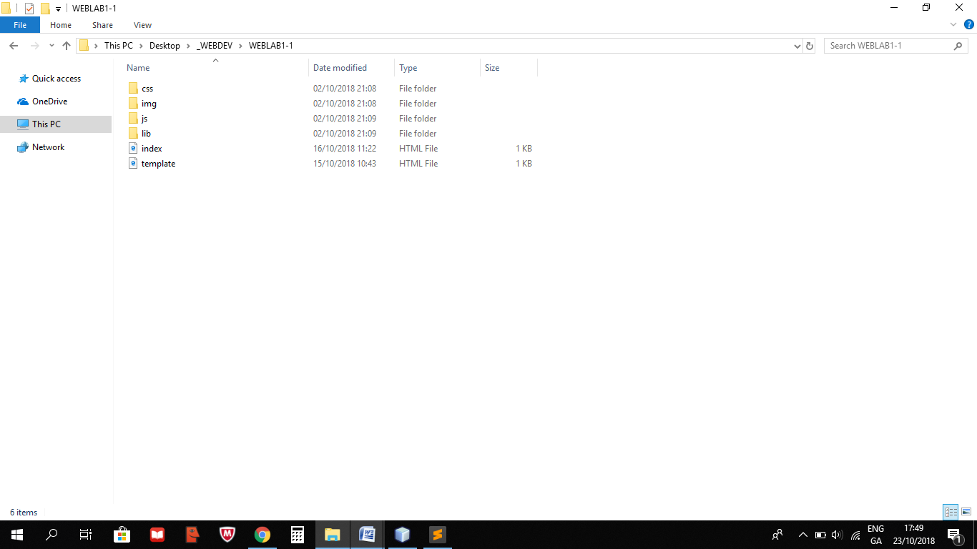

## Code

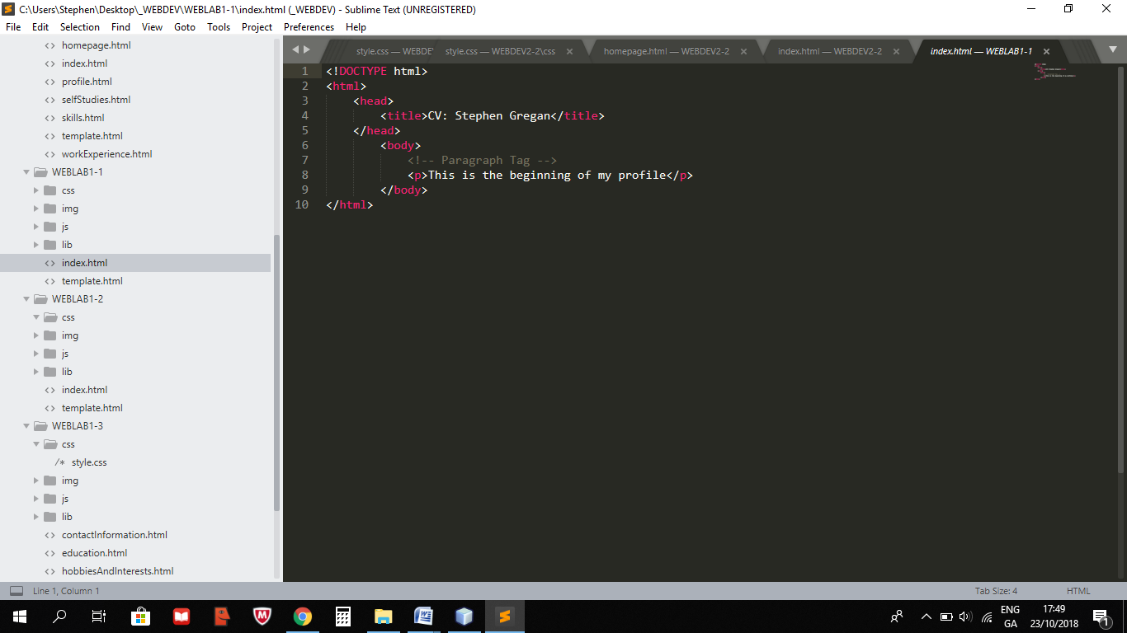

## Screens

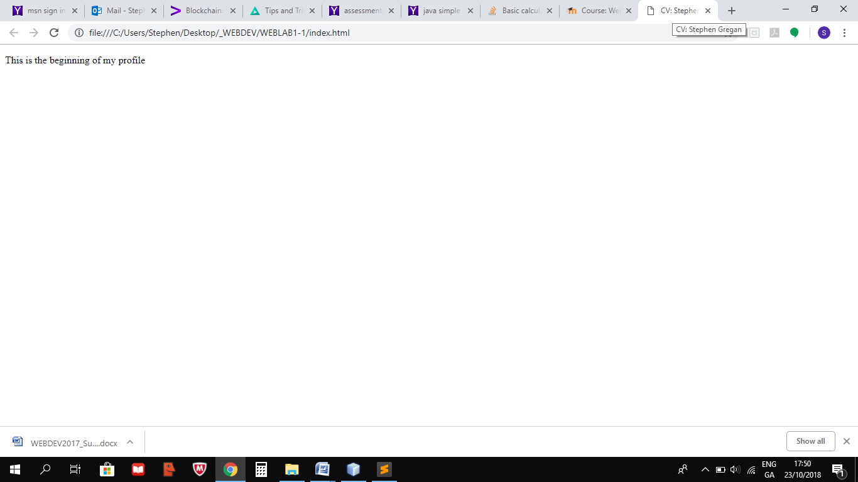

## Testing

Checked in Chrome and Internet Explorer.

## References

https://www.w3schools.com/

# Lab 1.2 : The Description

## Problem definition

Create a CV website with the minimum set of HTML tags required.

## Design

Display a webpage in the Chrome browser with

* <p>, <h1>, <h2>, <h3>, <h4>, <hr>, <i>, <b>, <strong>, <small>, <em>, <!-- -->

## Website folder structure

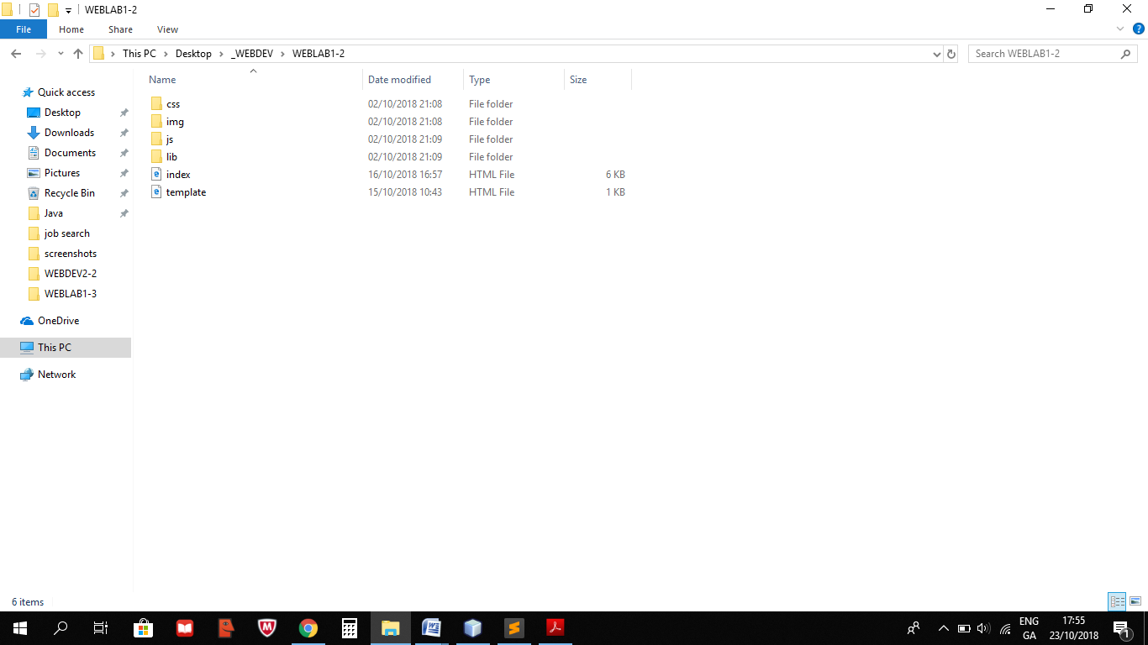

## Code

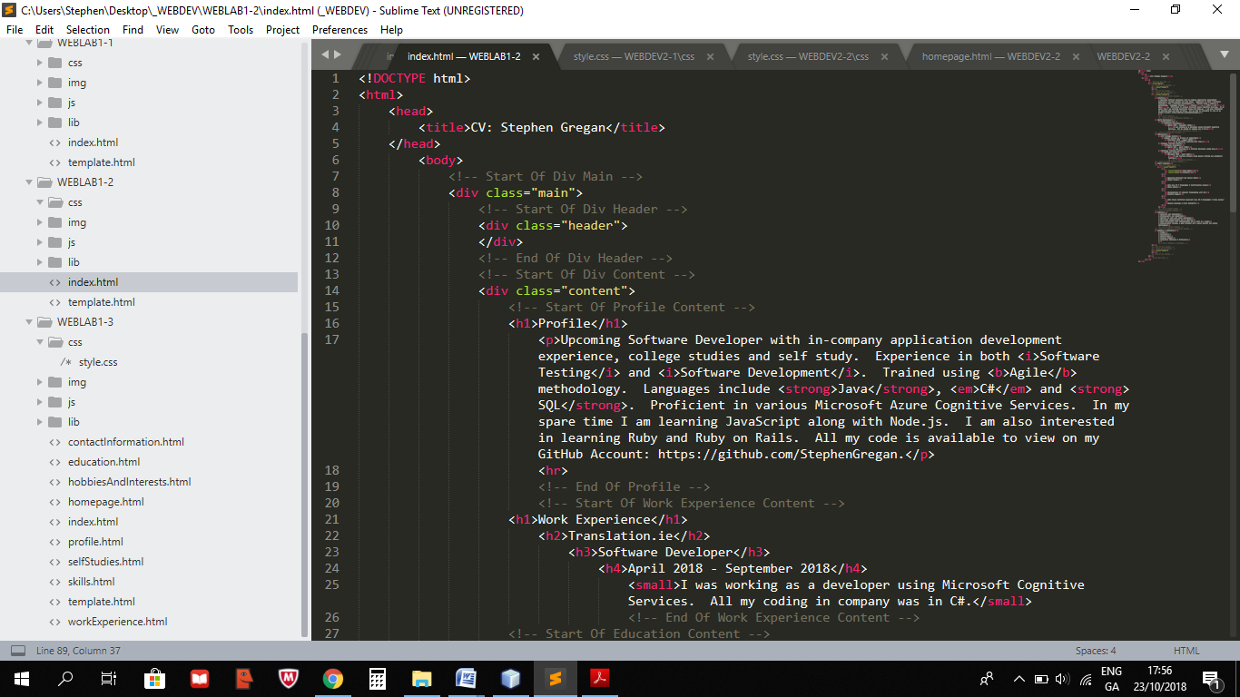

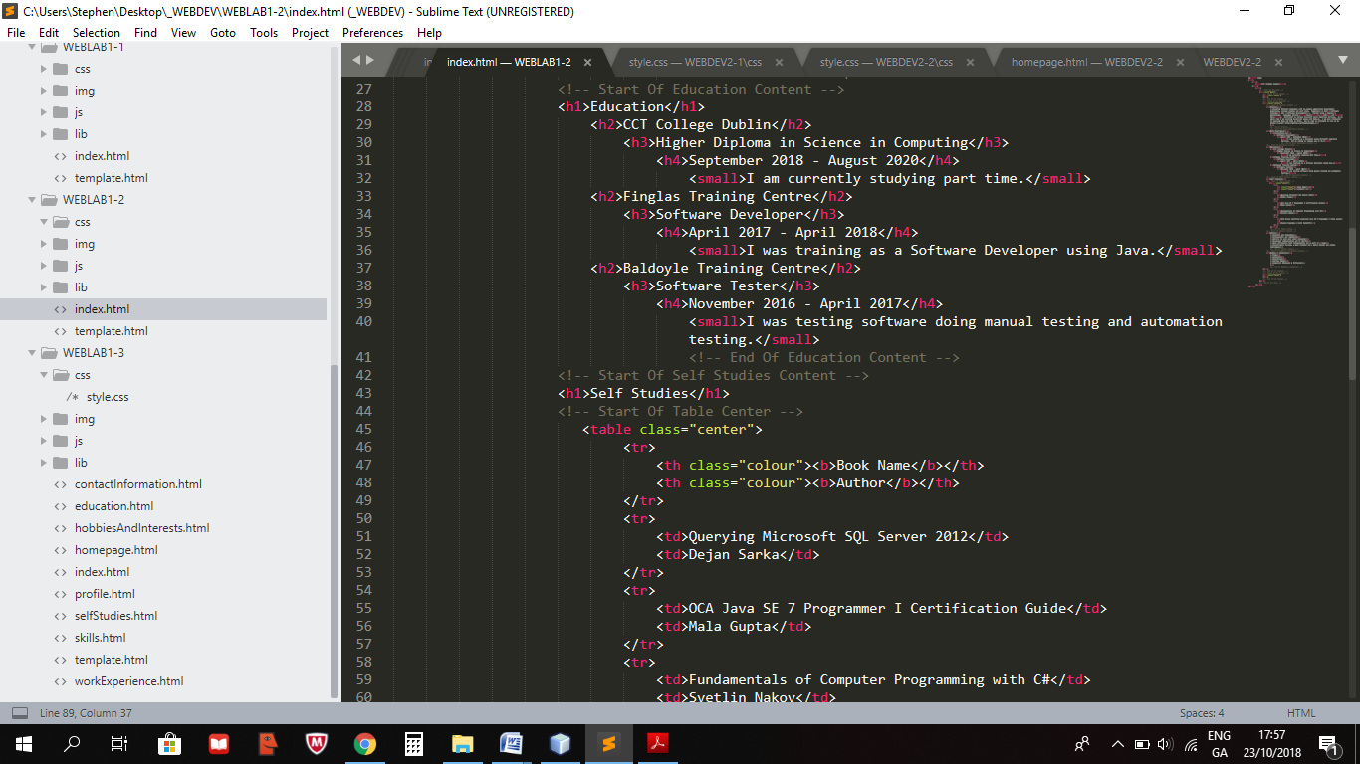

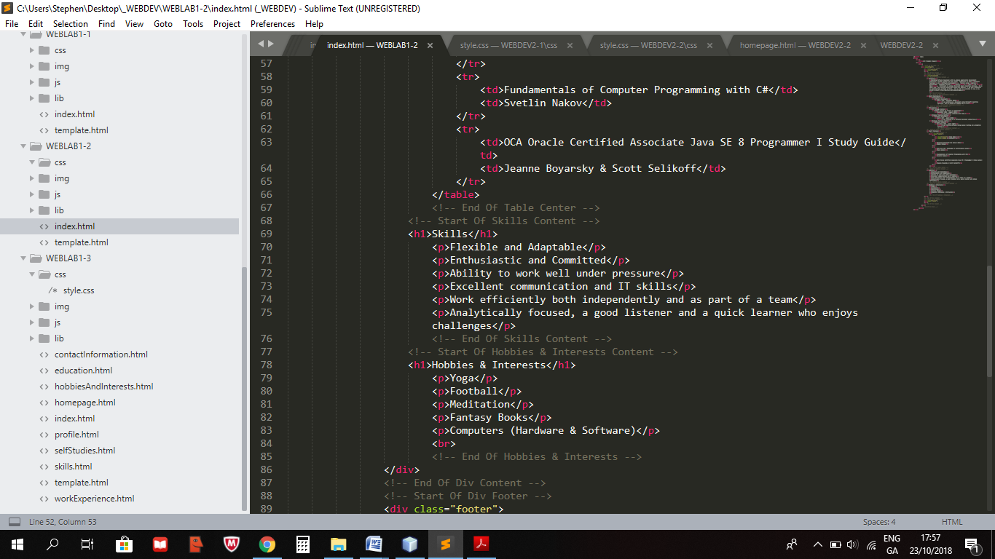

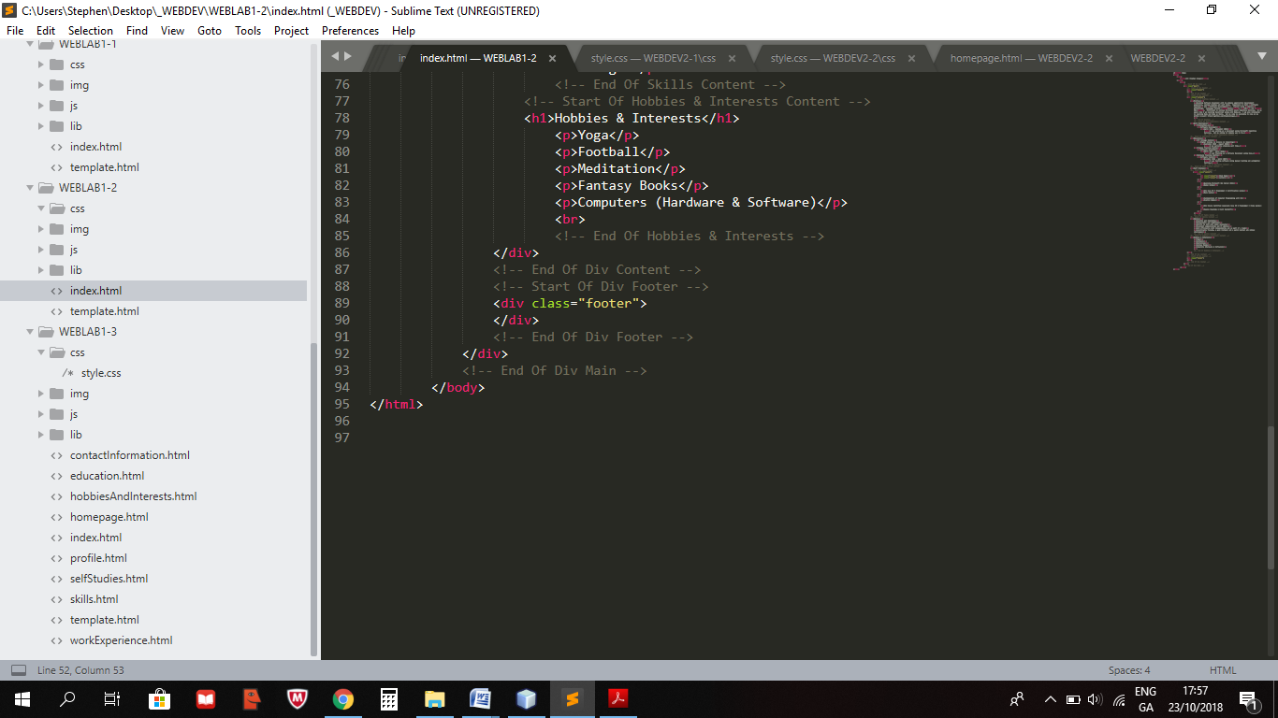

## Screens

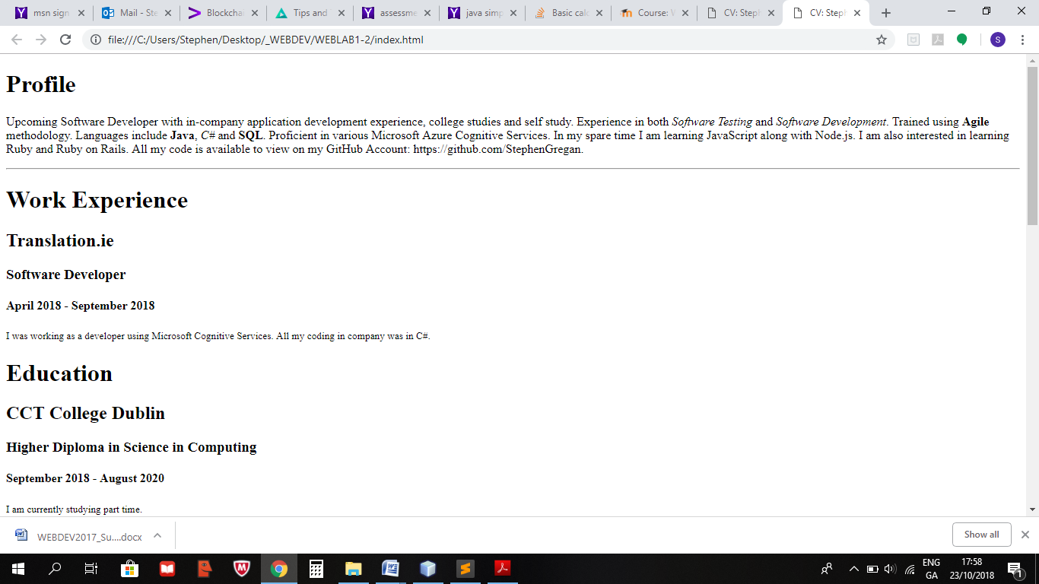

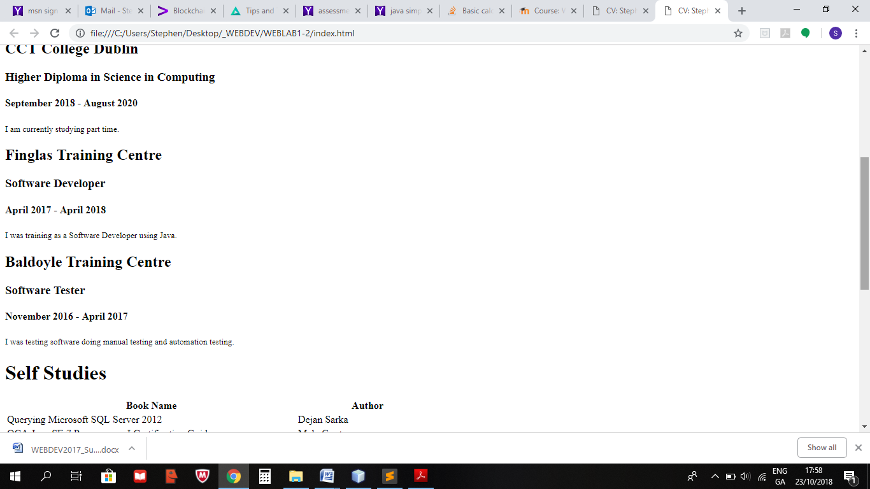

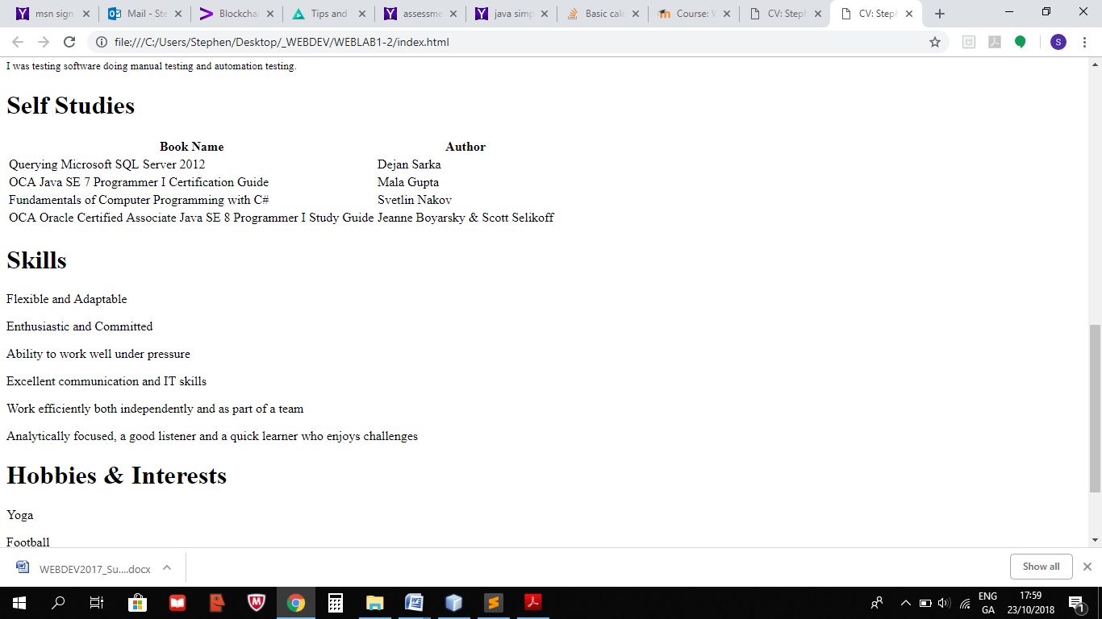

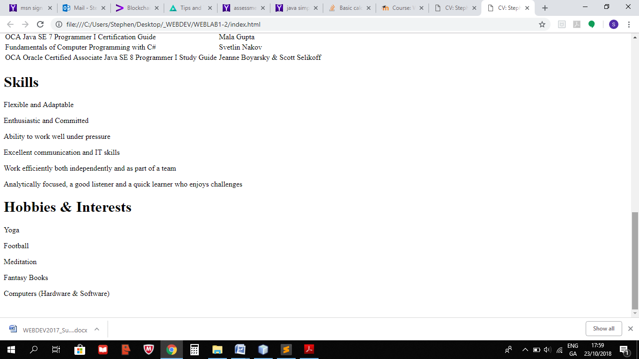

## Testing

Checked in Chrome and Internet Explorer.

## References

https://www.w3schools.com/

# 1.3 Lab write up template

## Problem definition

Create a CV website with at least 4 other HTML files containing links to the other files in the multi-page site, create a home icon that is a link back to index.html on each page.

## Design

Display a webpage in the Chrome browser with

* <p>, <h1>, <h2>, <h3>, <h4>, <hr>, <i>, <b>, <strong>, <small>, <em>, !-- -->, <img>, <table>, <a>,
* <ul>, <ol>, <li>

## Website folder structure

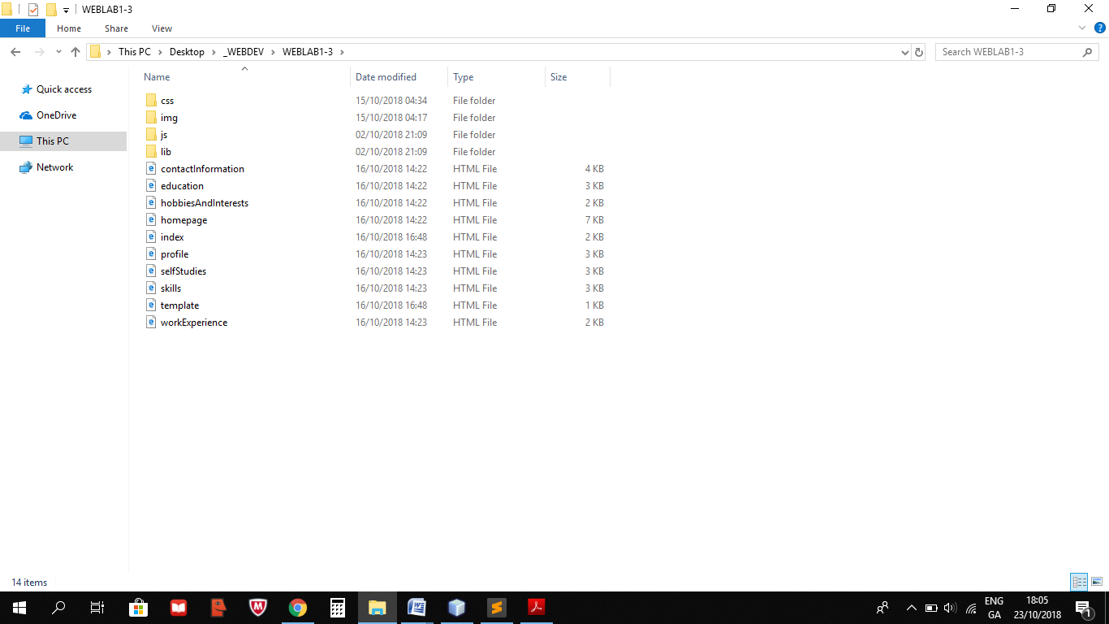

## Code

**Index.html**

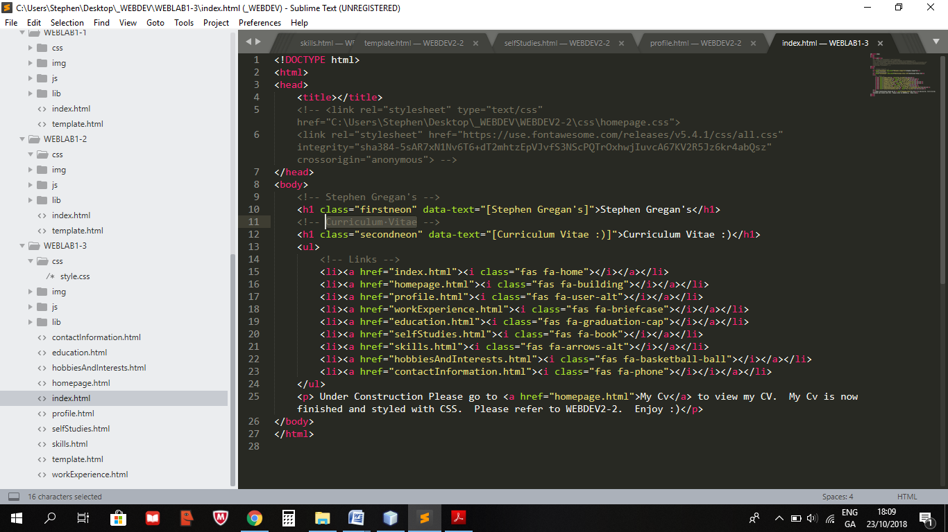

**Homepage.html**

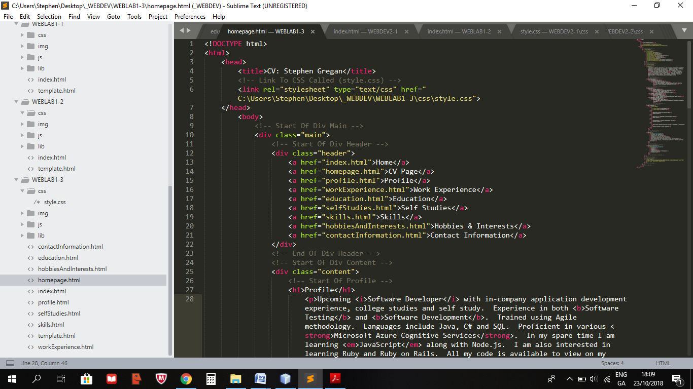

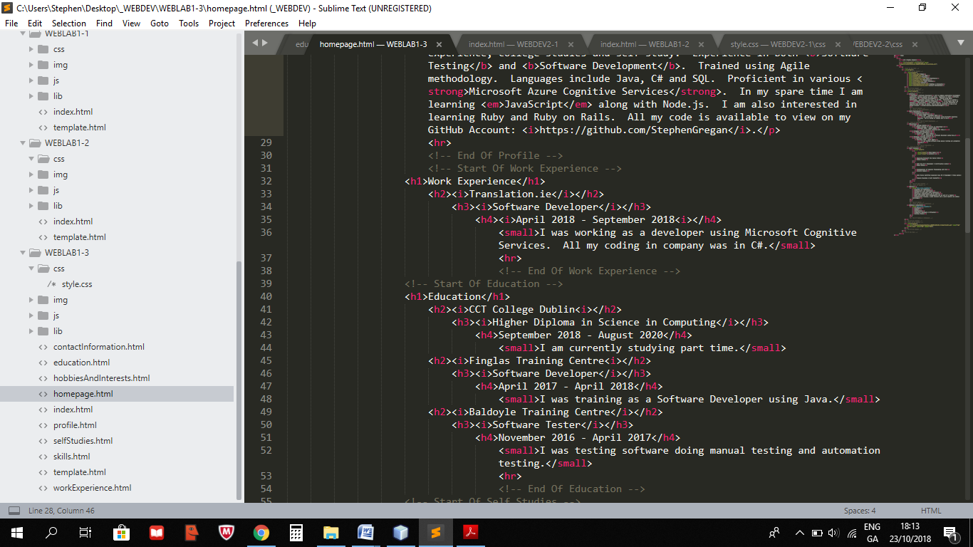

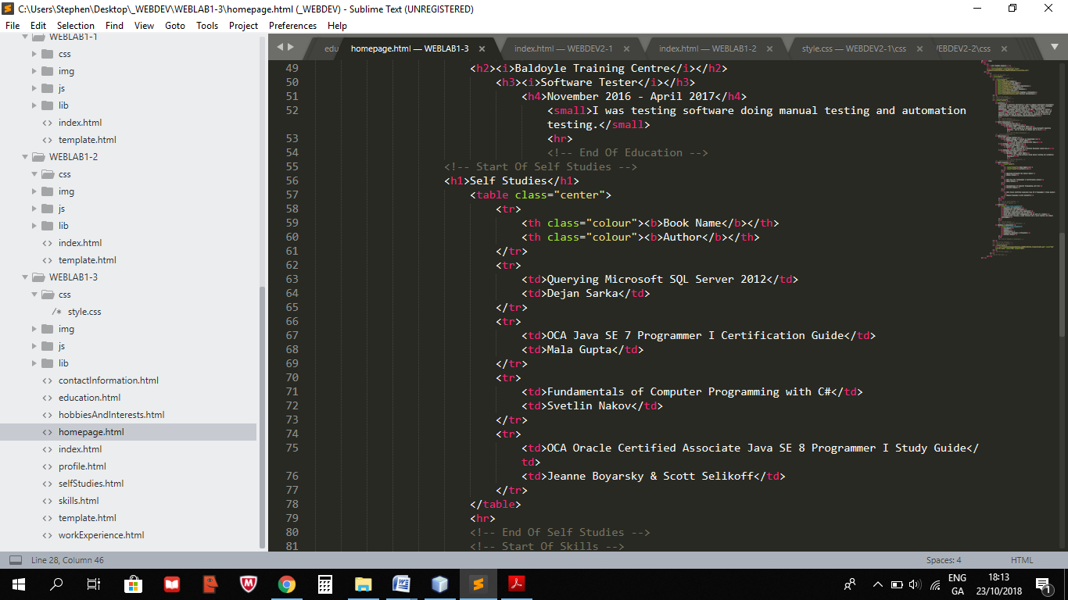

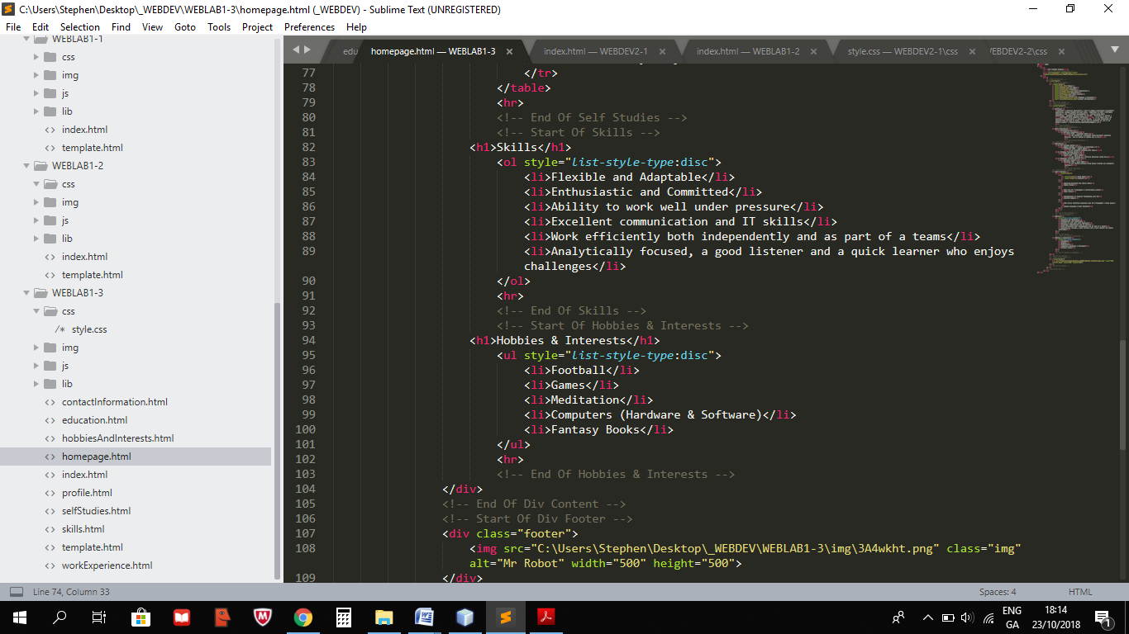

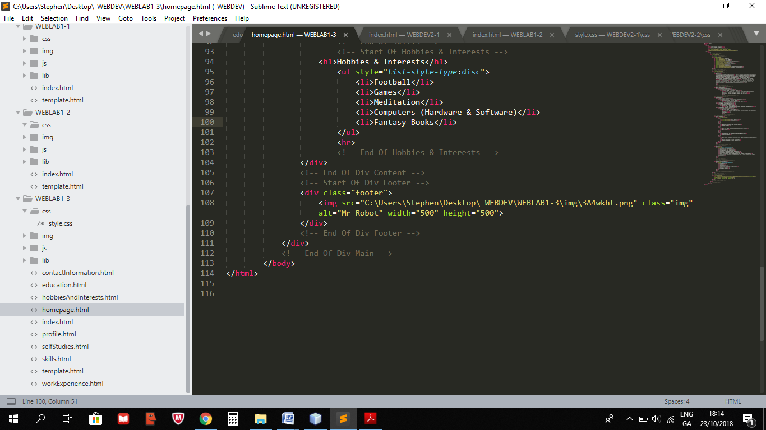

**Profile.html**

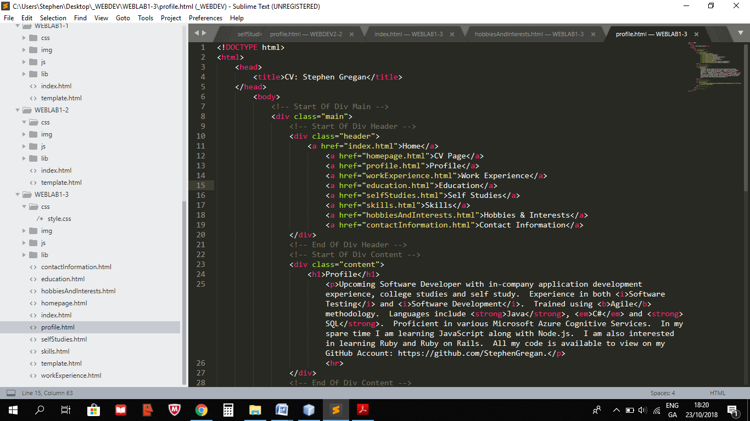

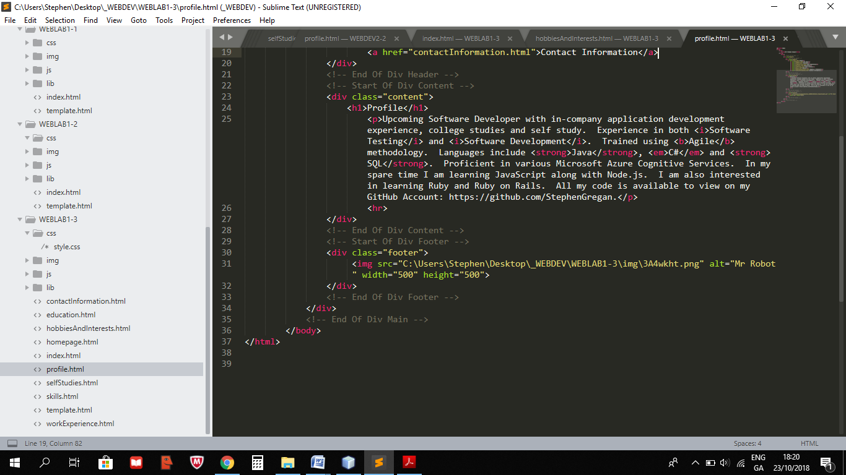

**WorkExperience.html**

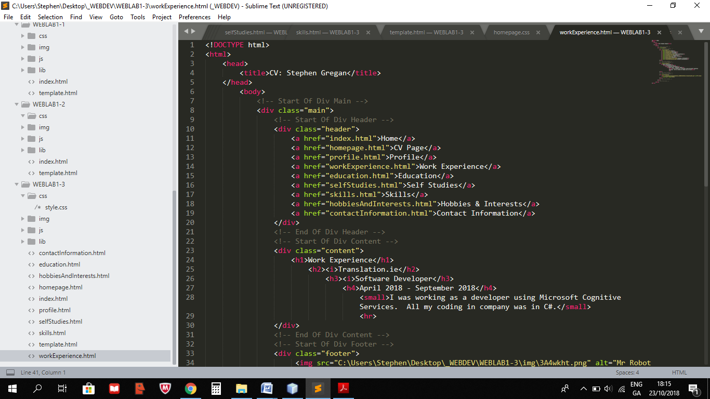

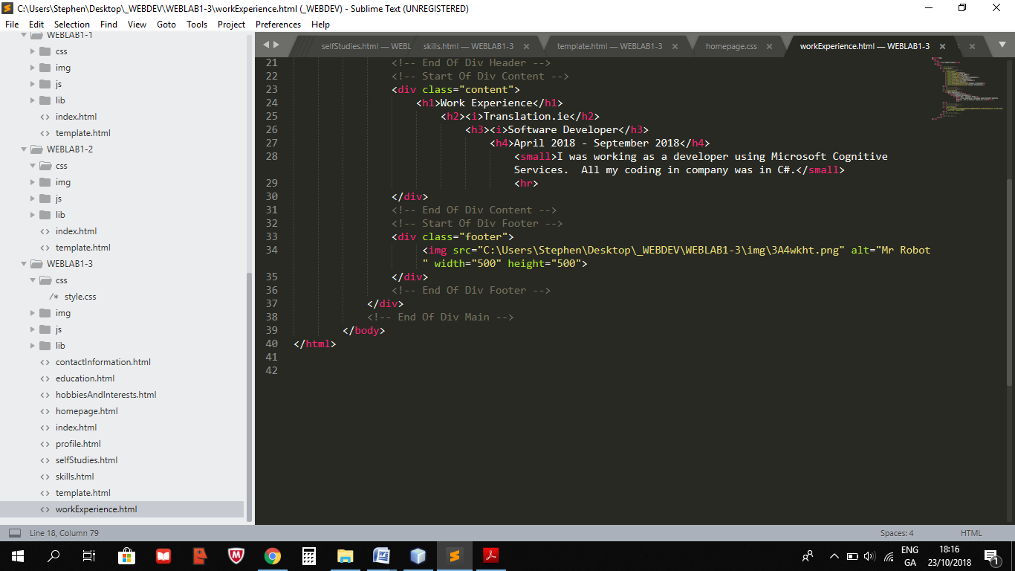

**Education.html**

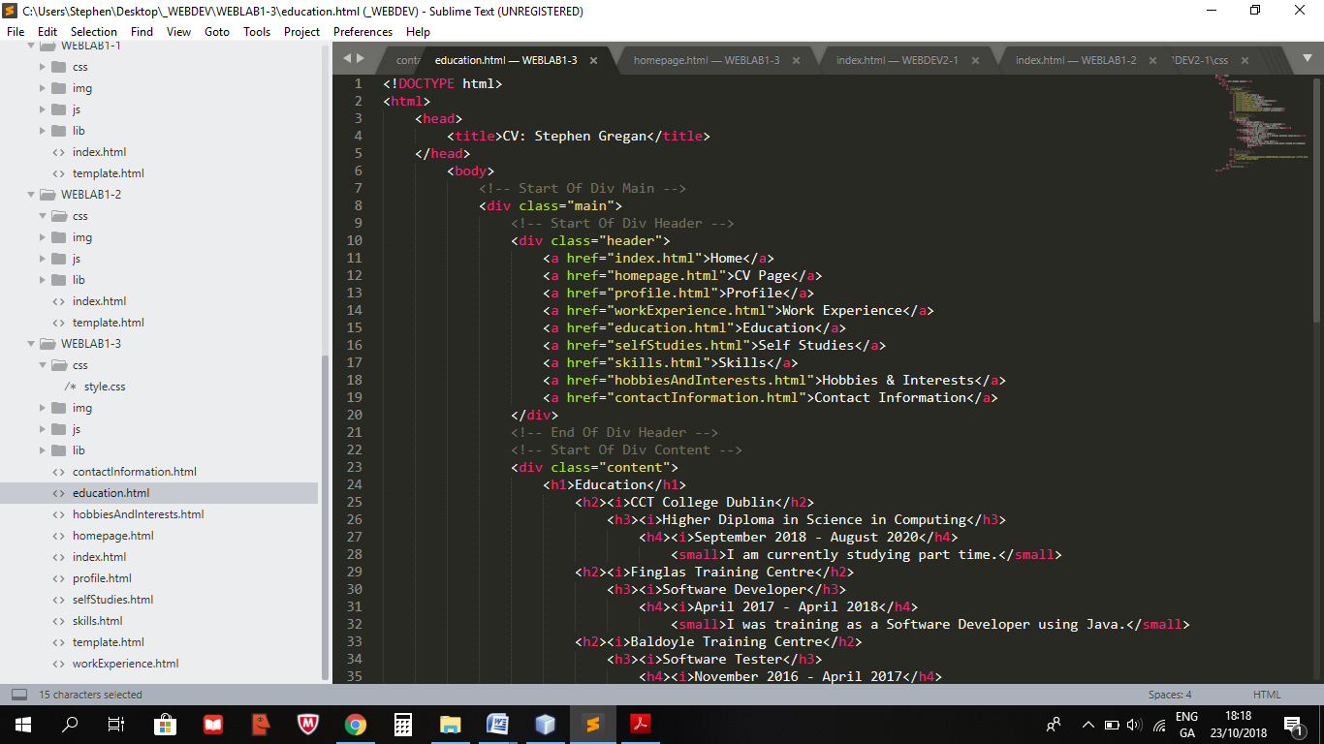

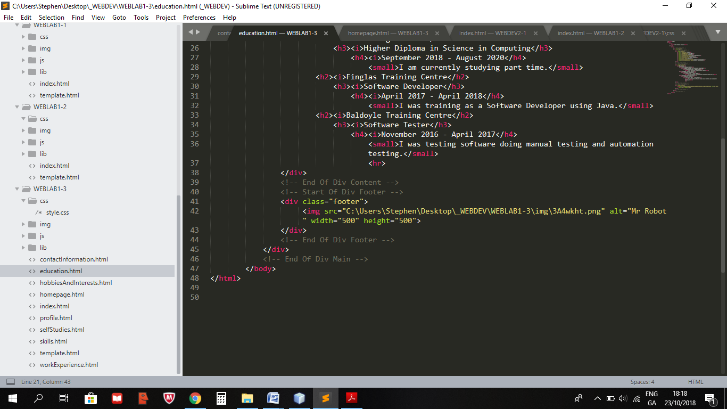

**SelfStudies.html**

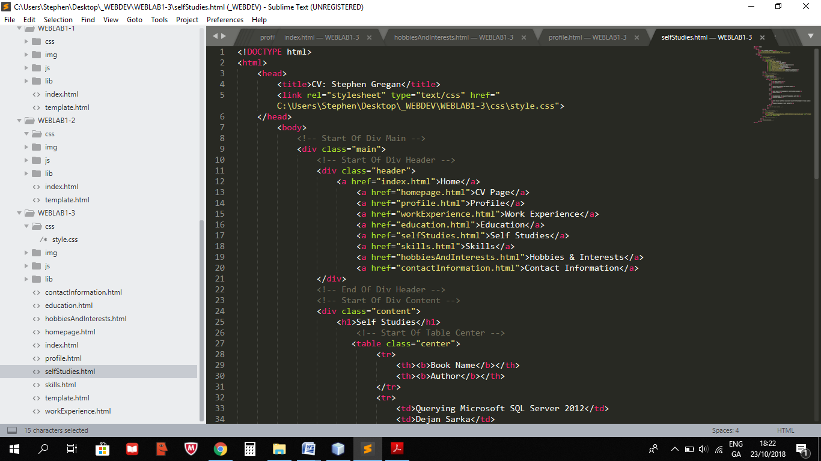

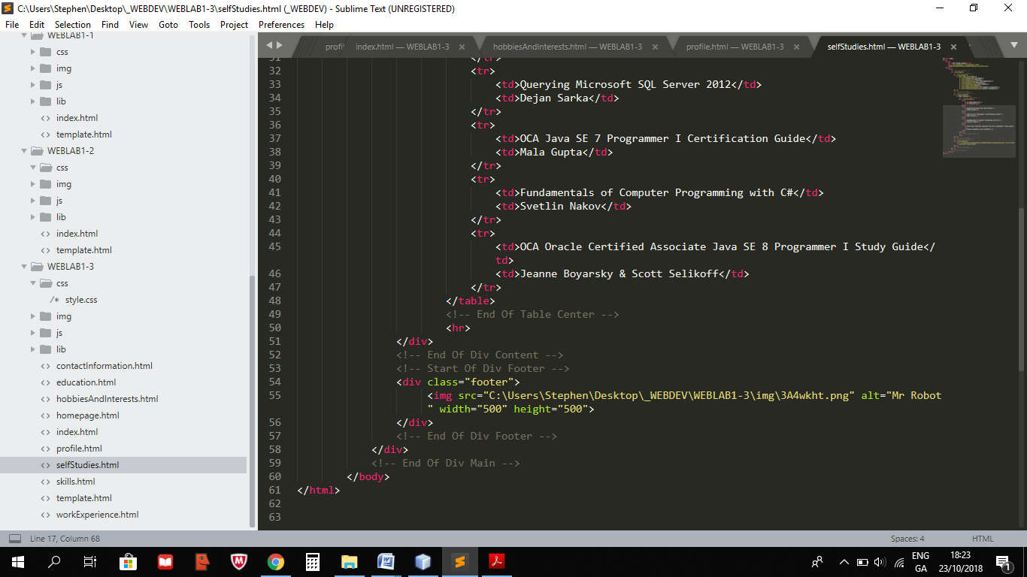

**Skills.html**

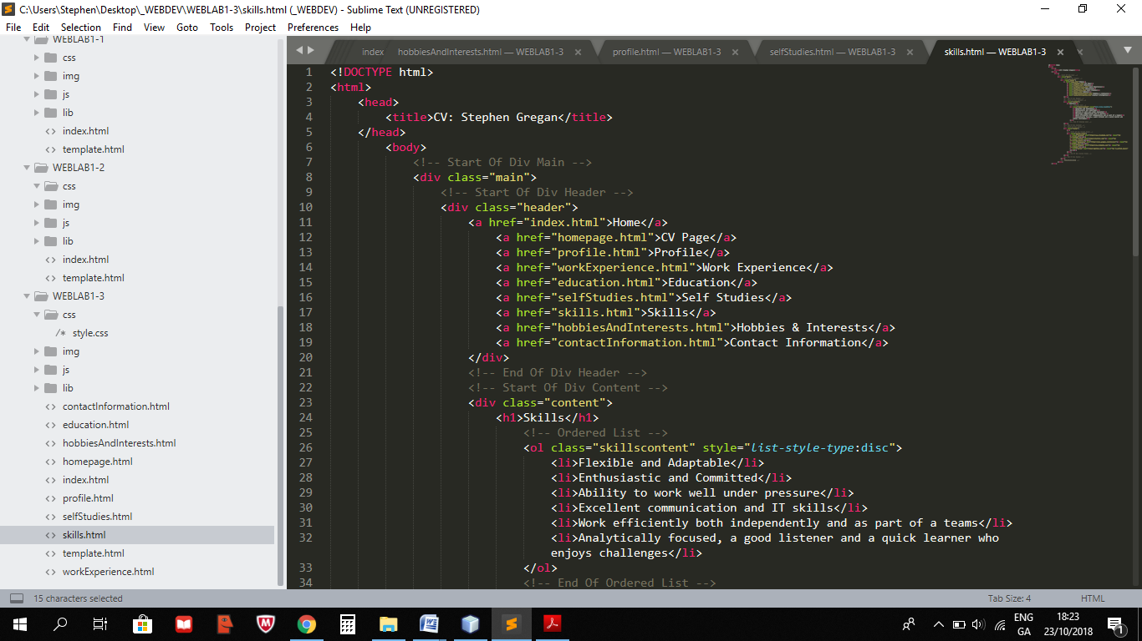

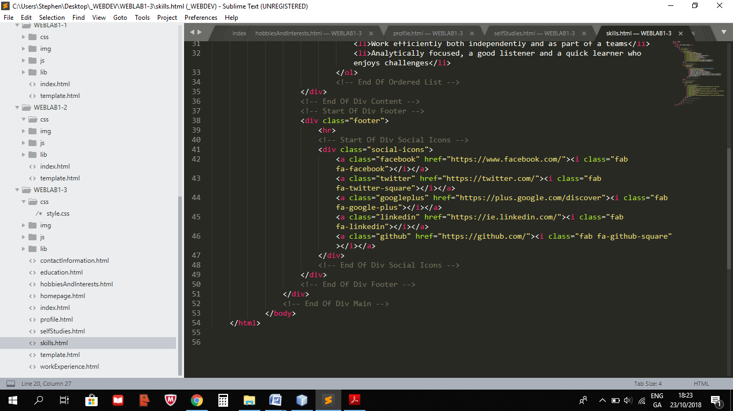

**HobbiesAndInterests.html**

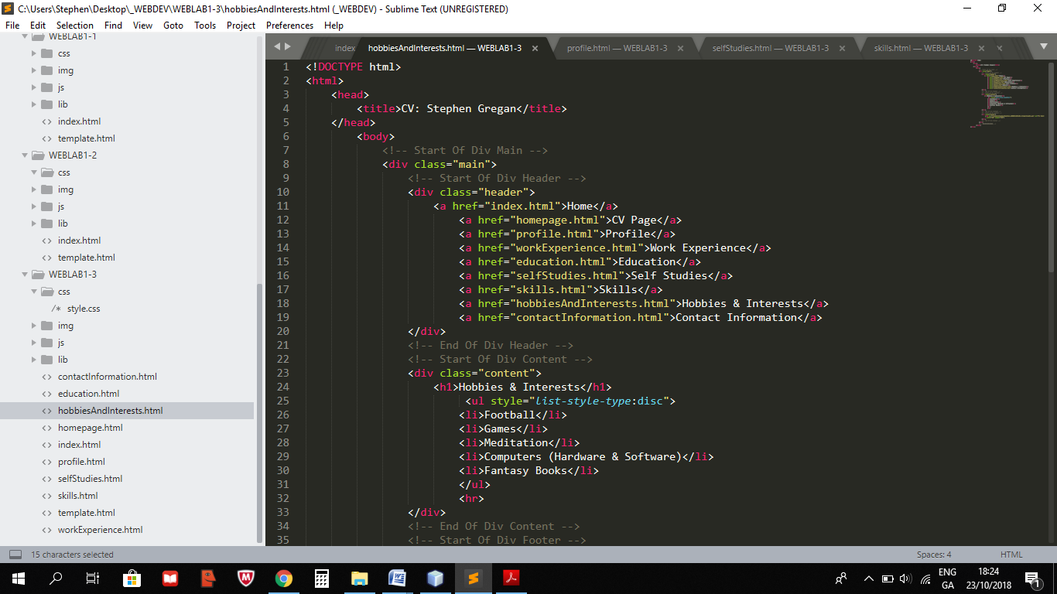

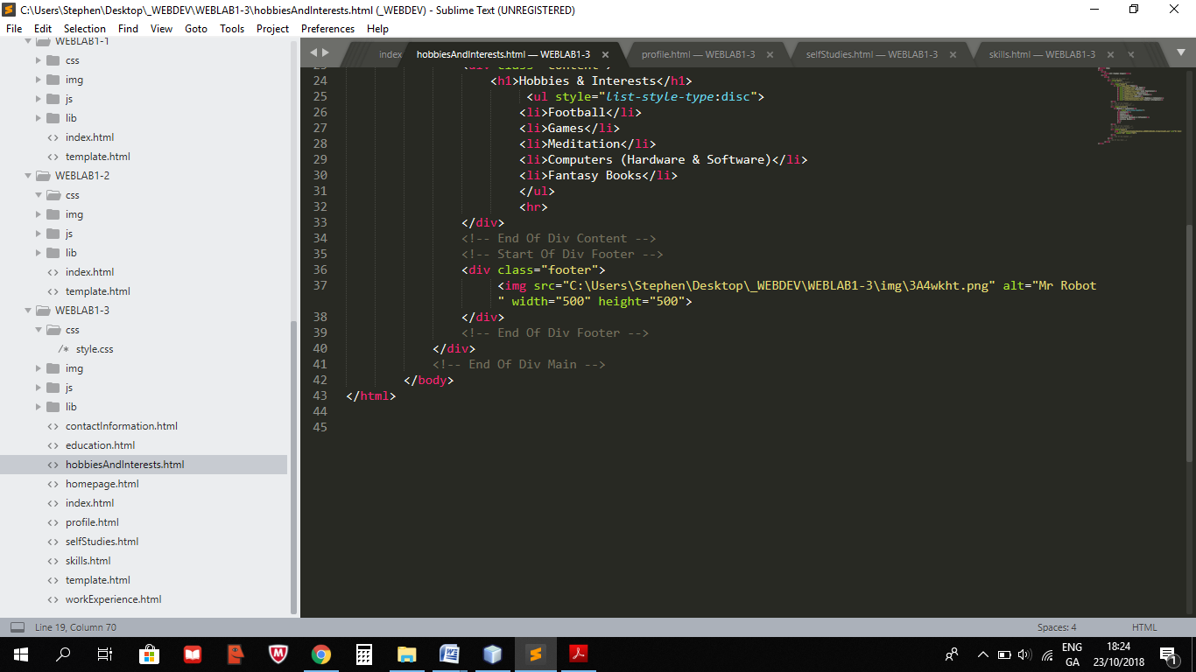

**ContactInformation.html**

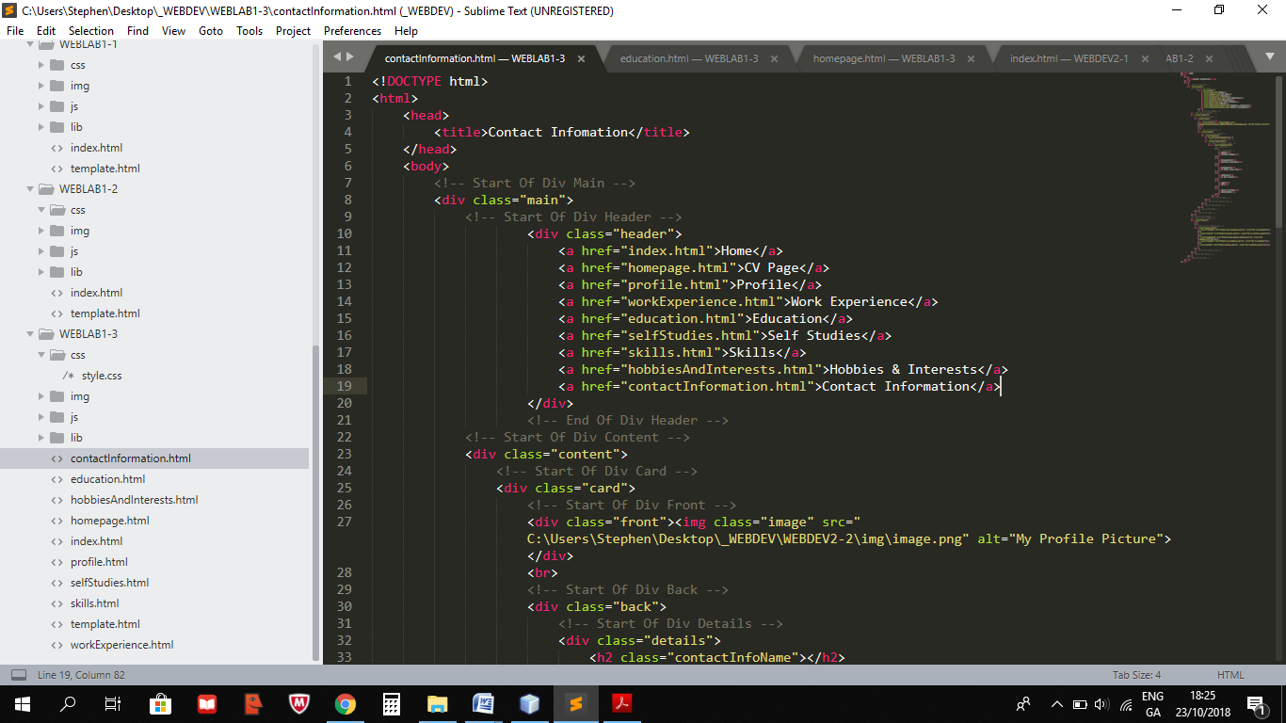

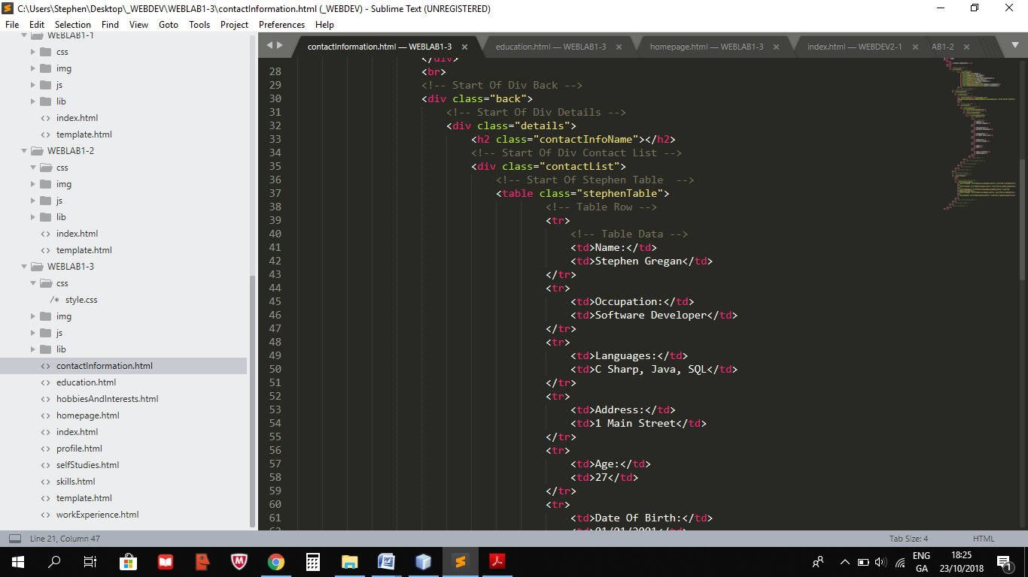

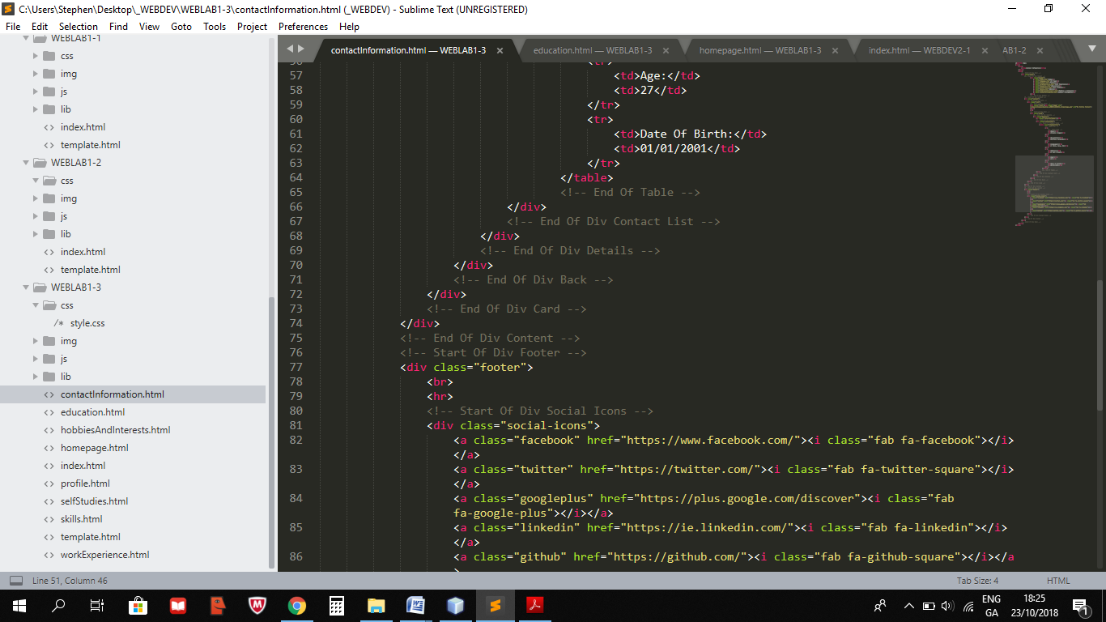

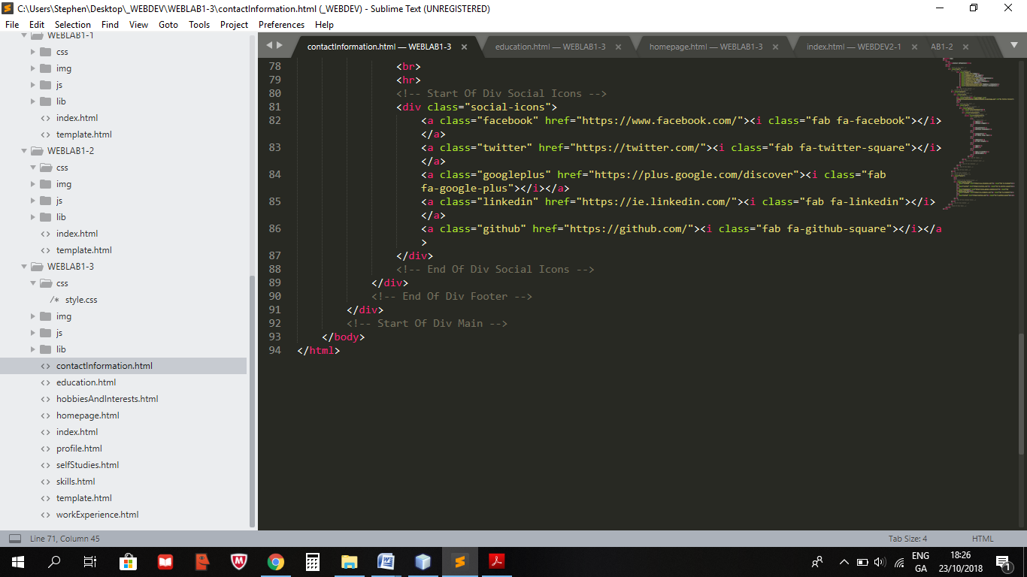

**Style.css**

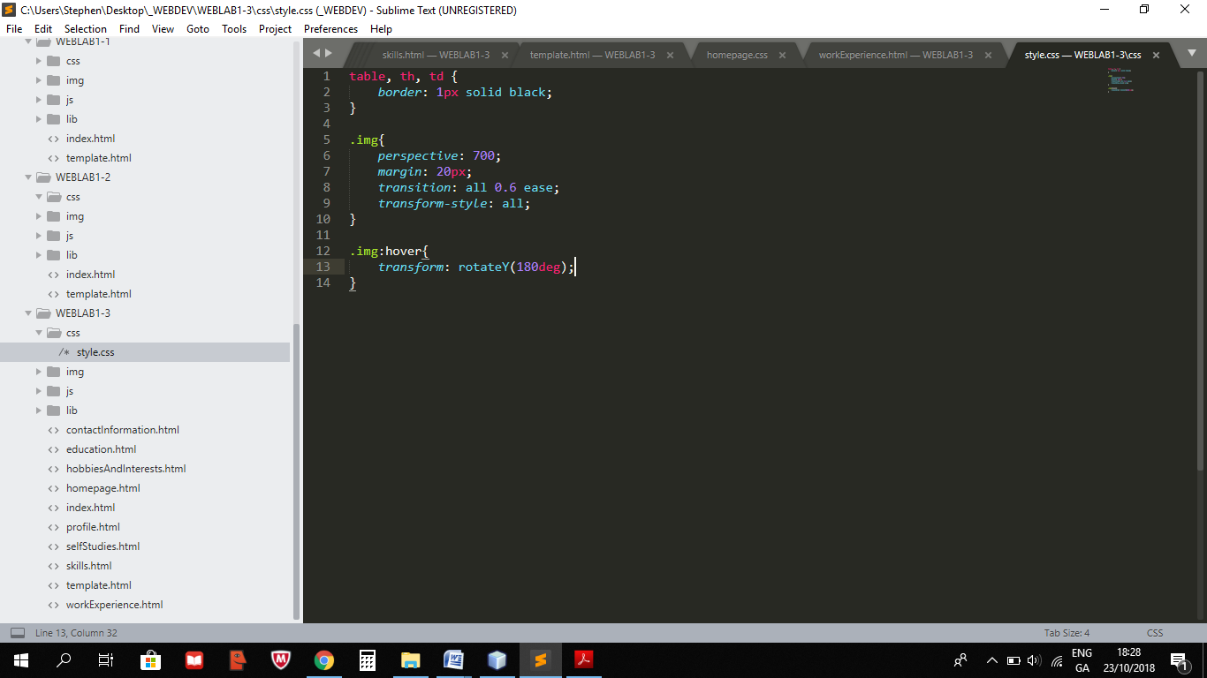

## Screens

**Index.html**

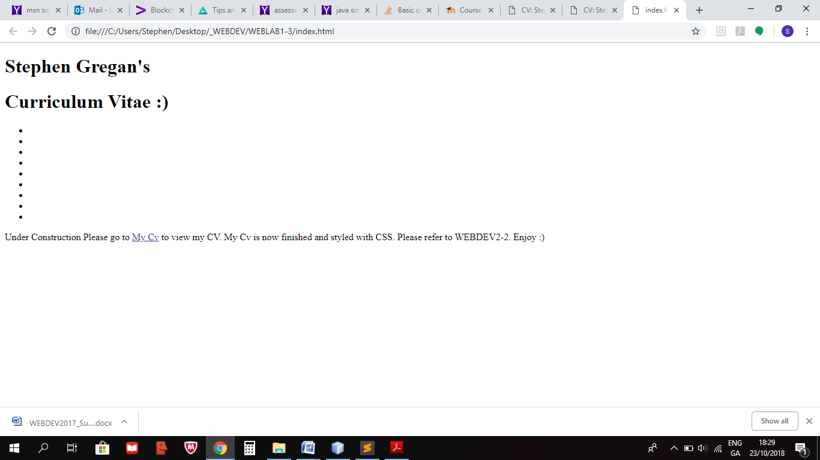

**Homepage.html**

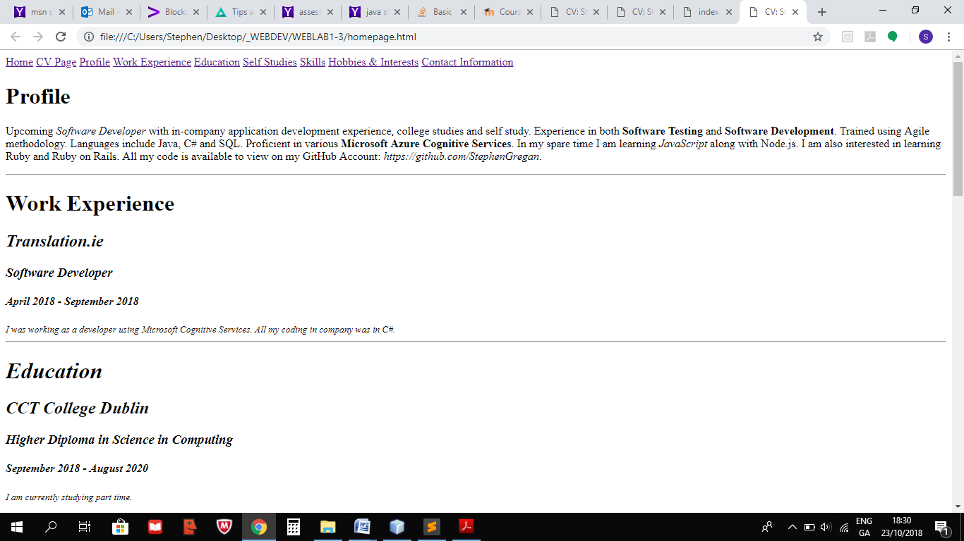

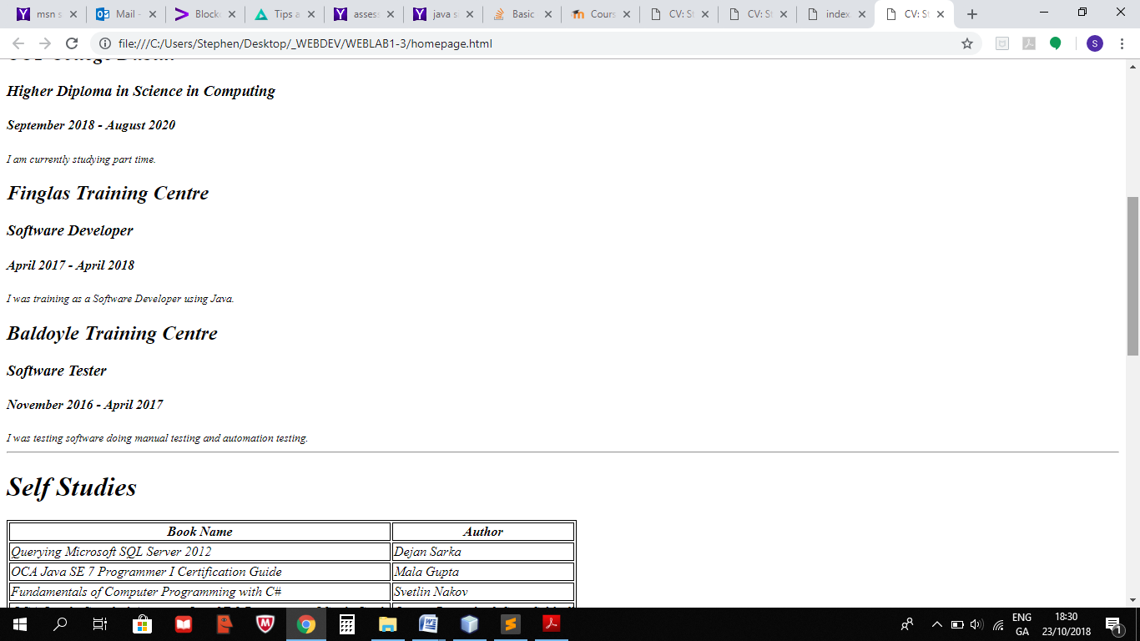

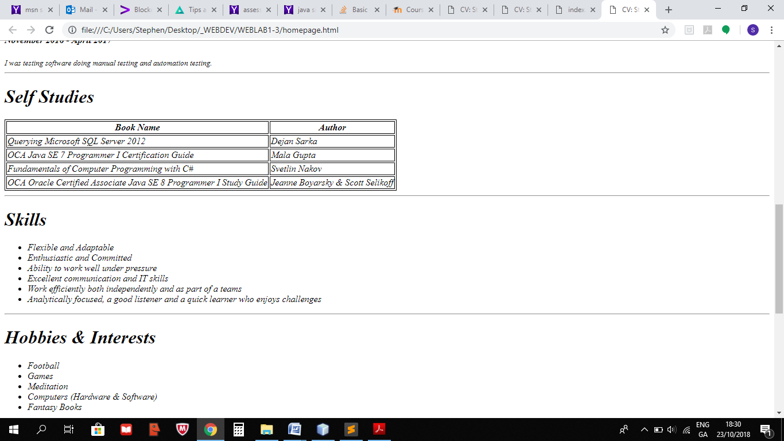

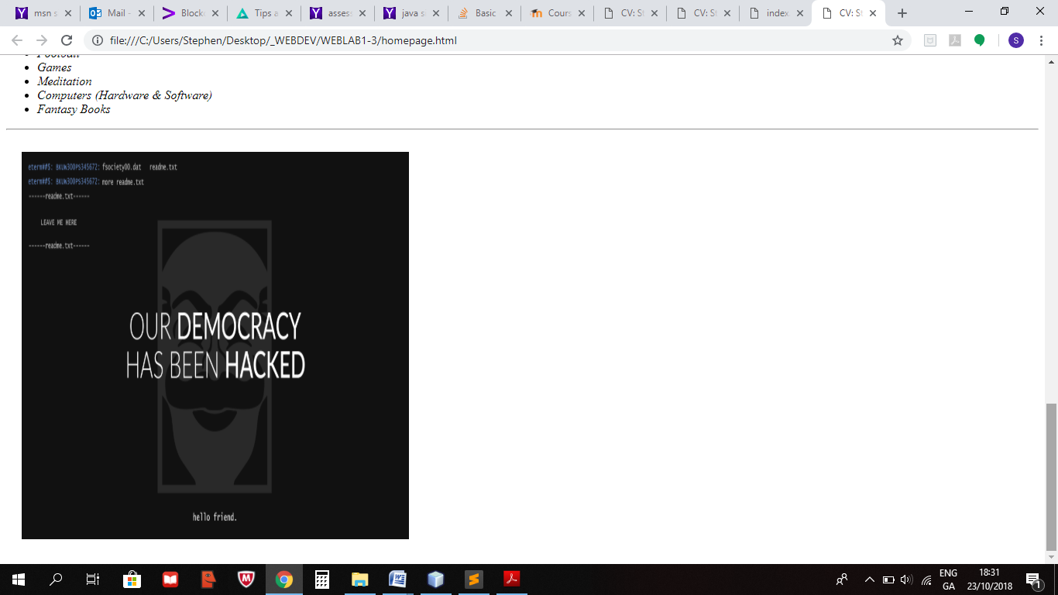

**Profile.html**

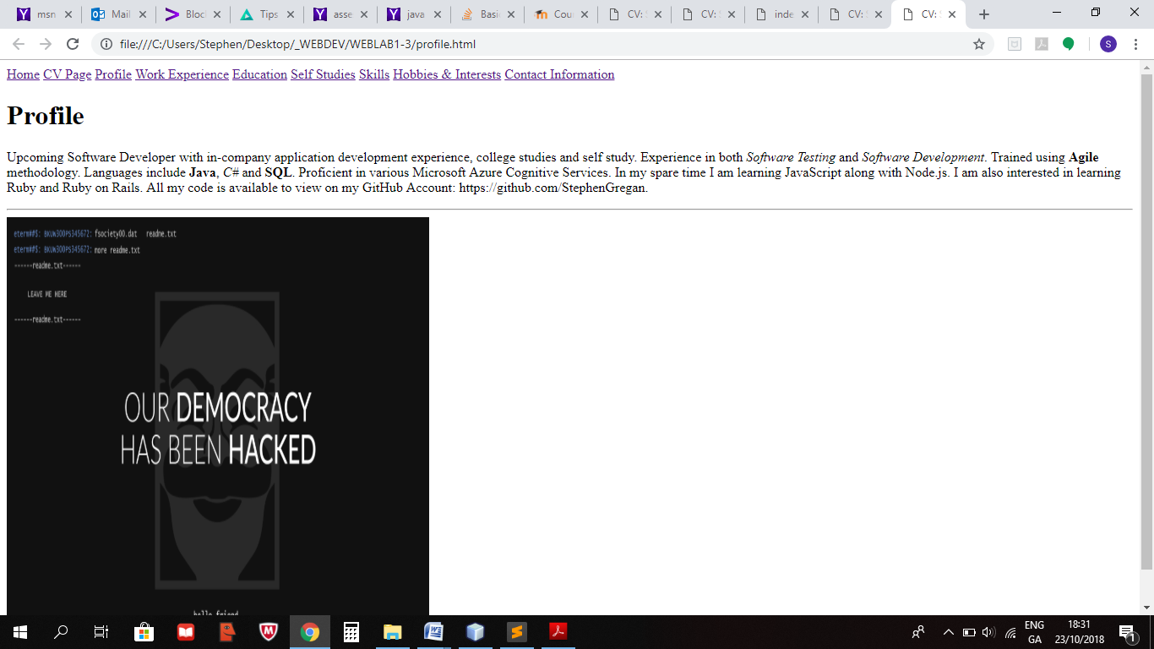

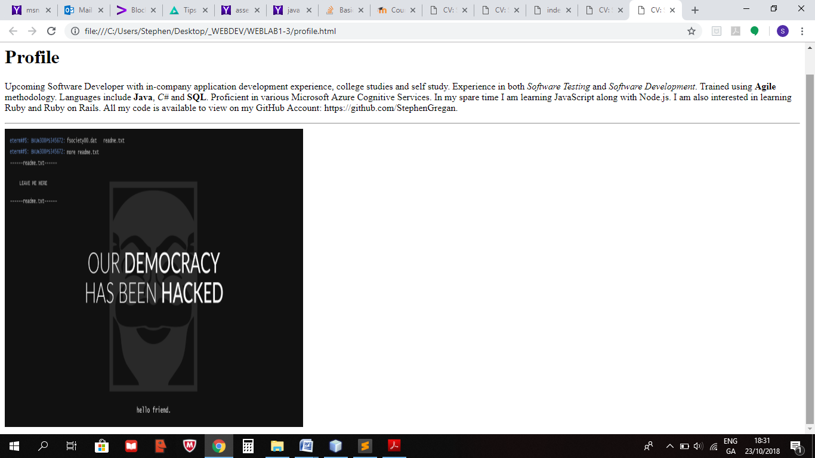

**WorkExperience.html**

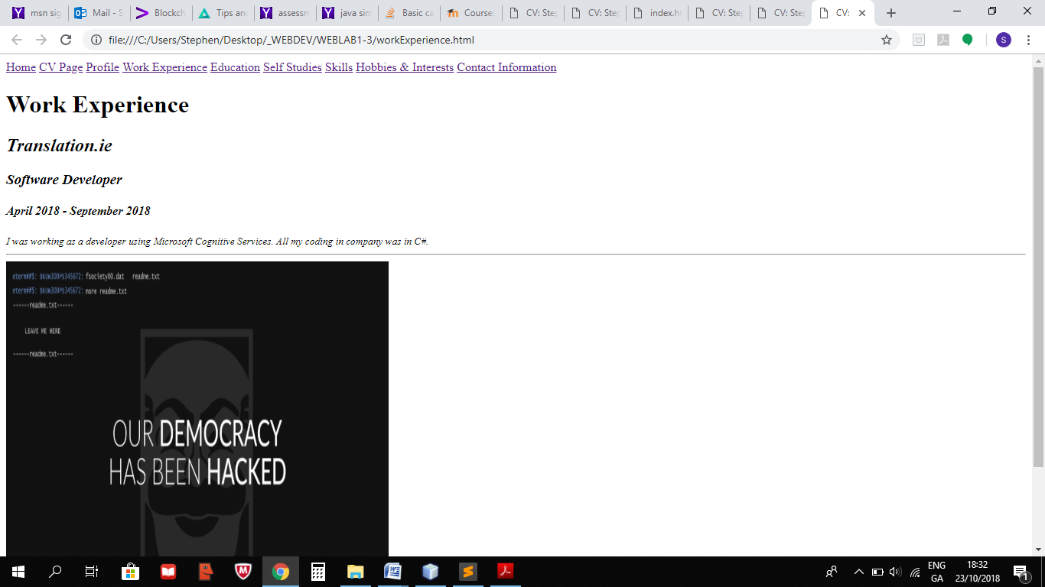

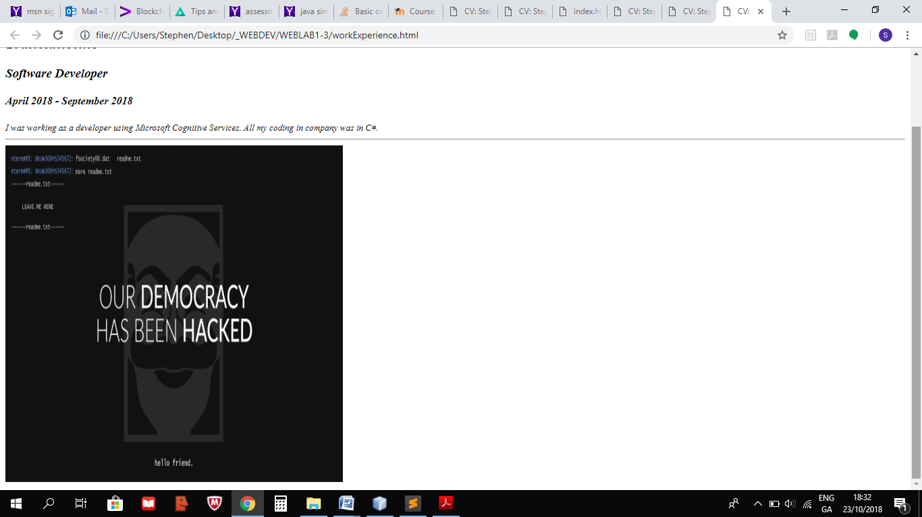

**Education.html**

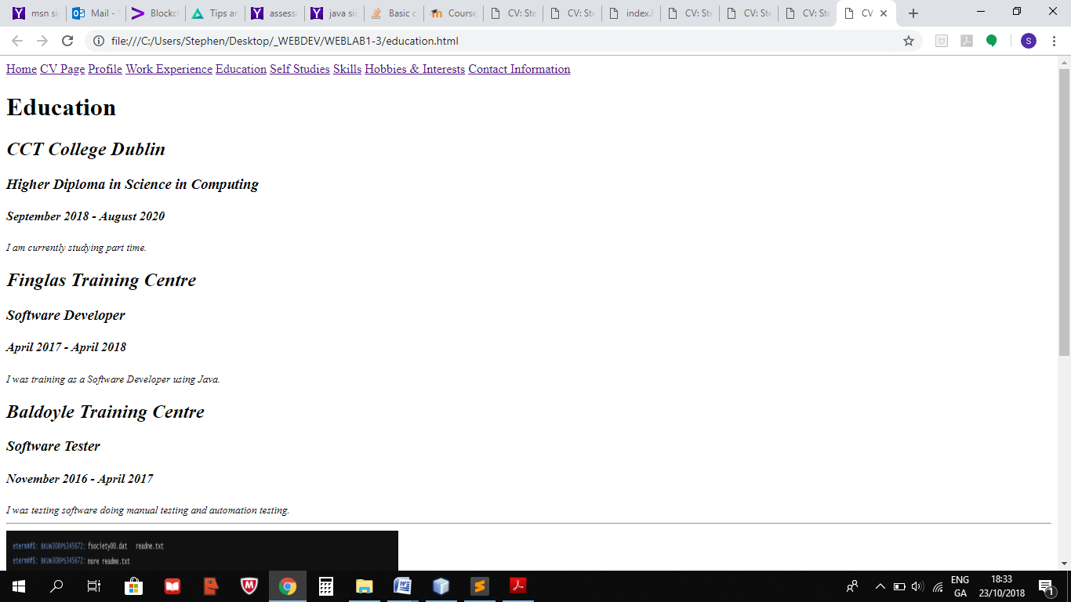

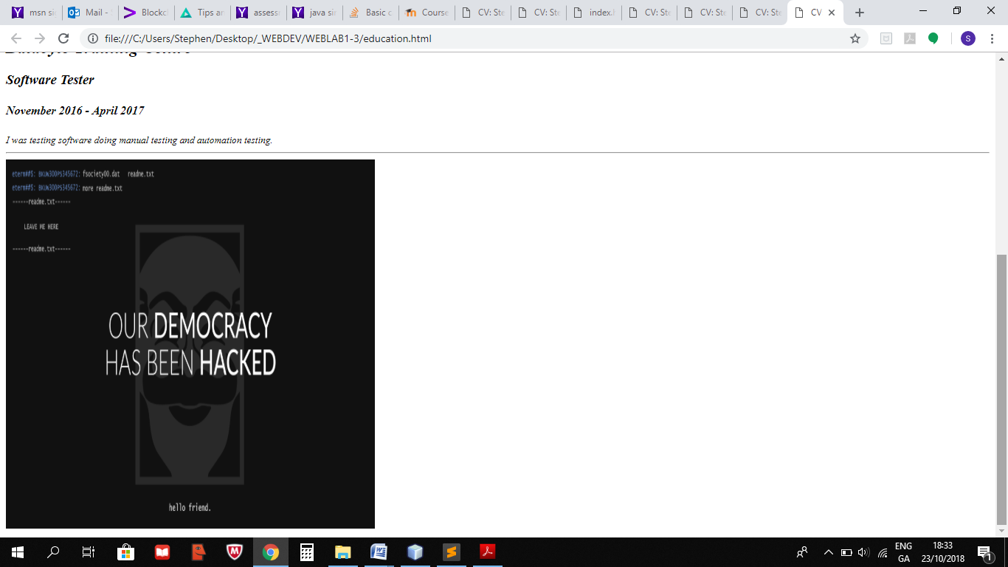

**SelfStudies.html**

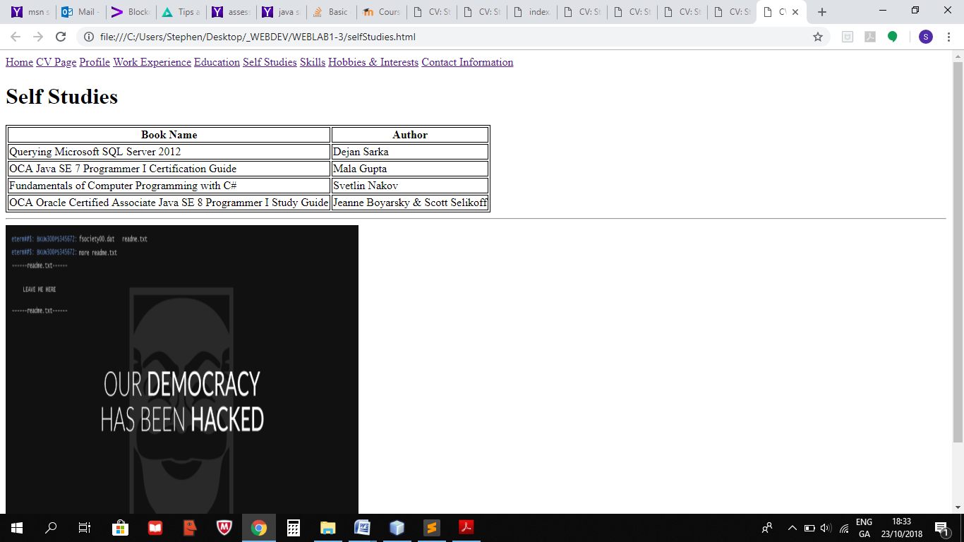

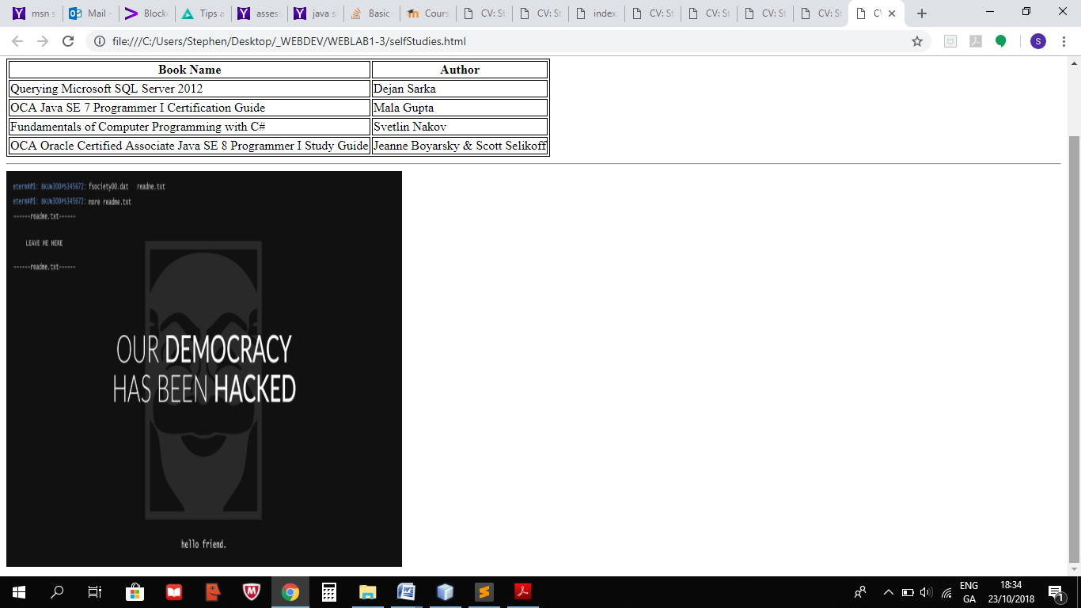

**Skills.html**

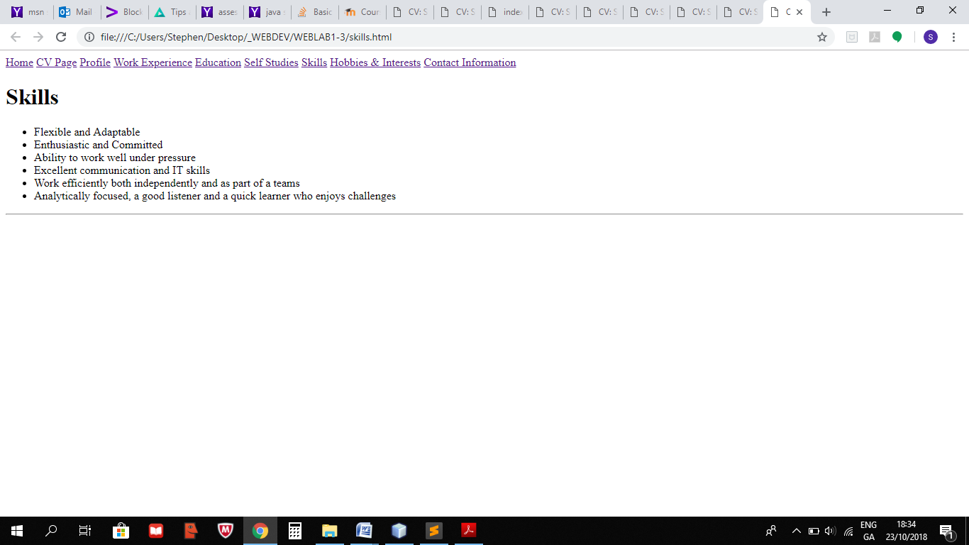

**HobbiesAndInterests.html**

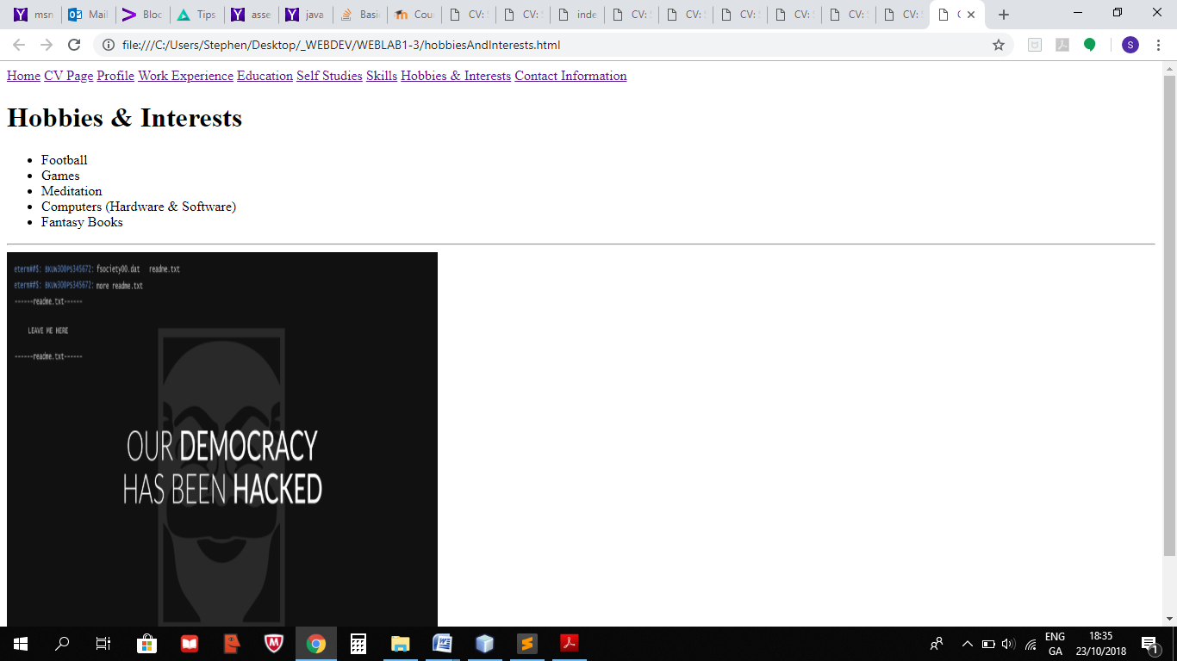

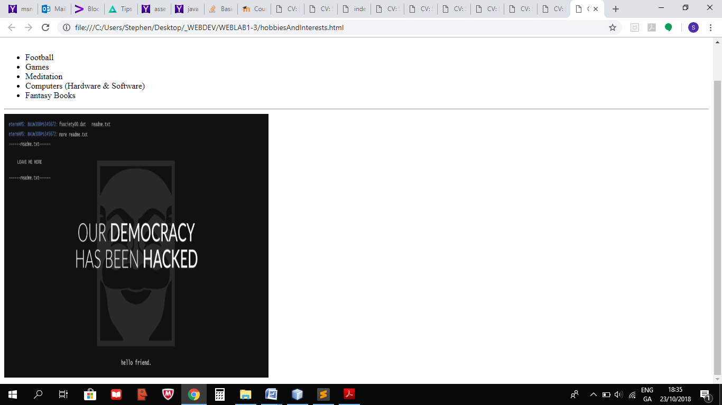

**ContactInformation.html**

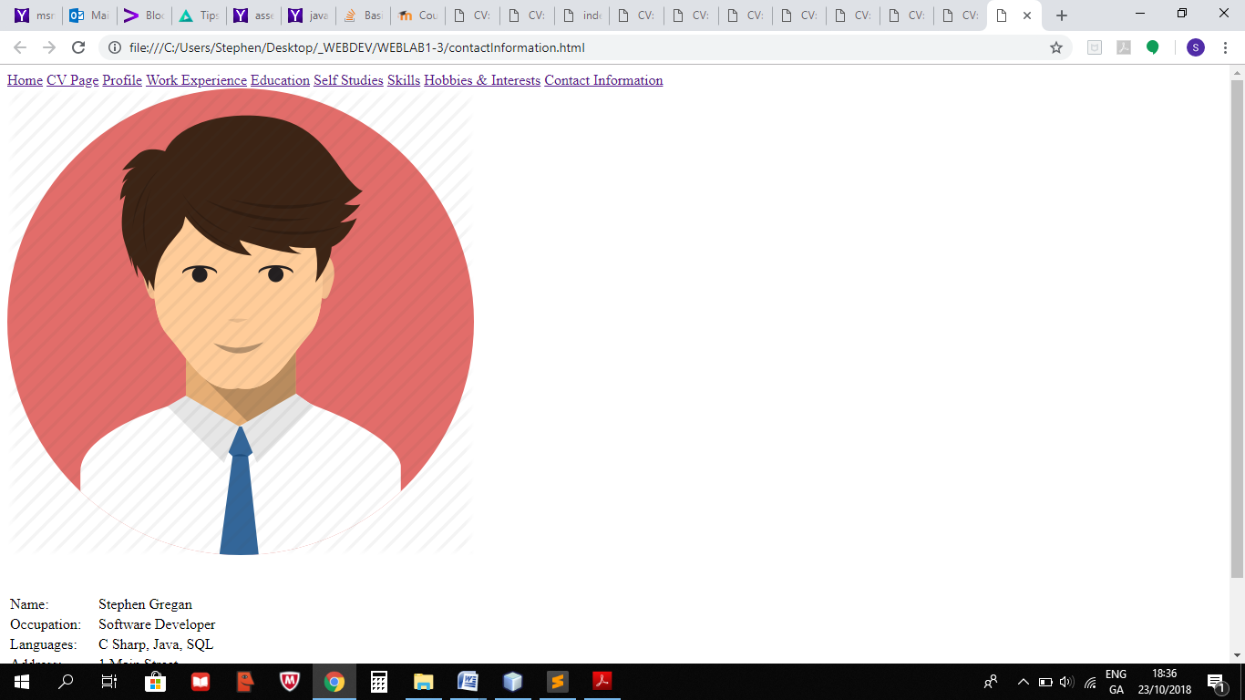

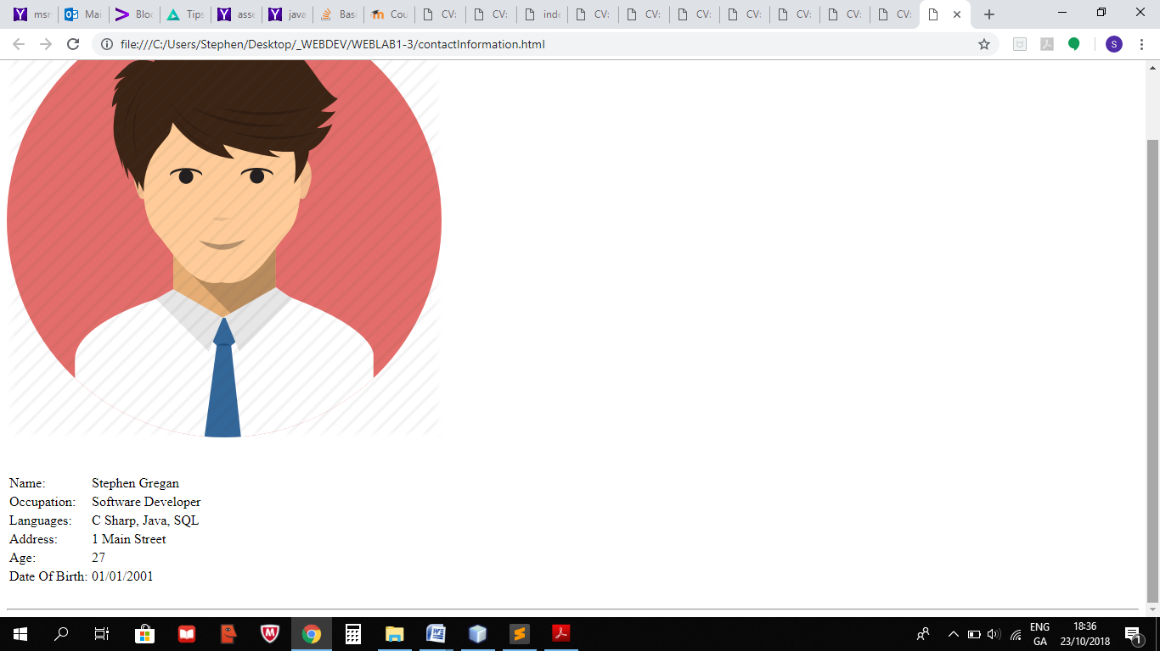

## Testing

Checked in Chrome, Firefox and Internet Explorer.

## References

https://www.w3schools.com/